Multi-User Login Setup on Windows EC2
Step 1: Change Group Policy

1.Log in to the EC2 Windows instance using RDP.
2.Press Windows + R, type gpedit.msc, press Enter.
3.Navigate: Computer Configuration → Administrative Templates → Windows Components → Remote Desktop Services → 4.Remote Desktop Session Host → Connections
5.Open Restrict Remote Desktop Services users to a single session, set it to Disabled, click OK.
6.Open Limit number of connections, set it to Enabled, and enter 5 (or 10), click OK.
7.1.Close Group Policy and restart the server.

Step 2: Create Users

1.Right-click Start → click Computer Management.
Go to:
2.Right-click → New User, create user accounts like user1, user2, etc., set passwords, click Create.

Step 3: Give RDP Access

1.Press Windows + R, type SystemPropertiesRemote, press Enter.
2.Click Select Users → Add.
3.Add all new users (user1, user2, …) → click OK.

Step:1 Create EC2 Instance
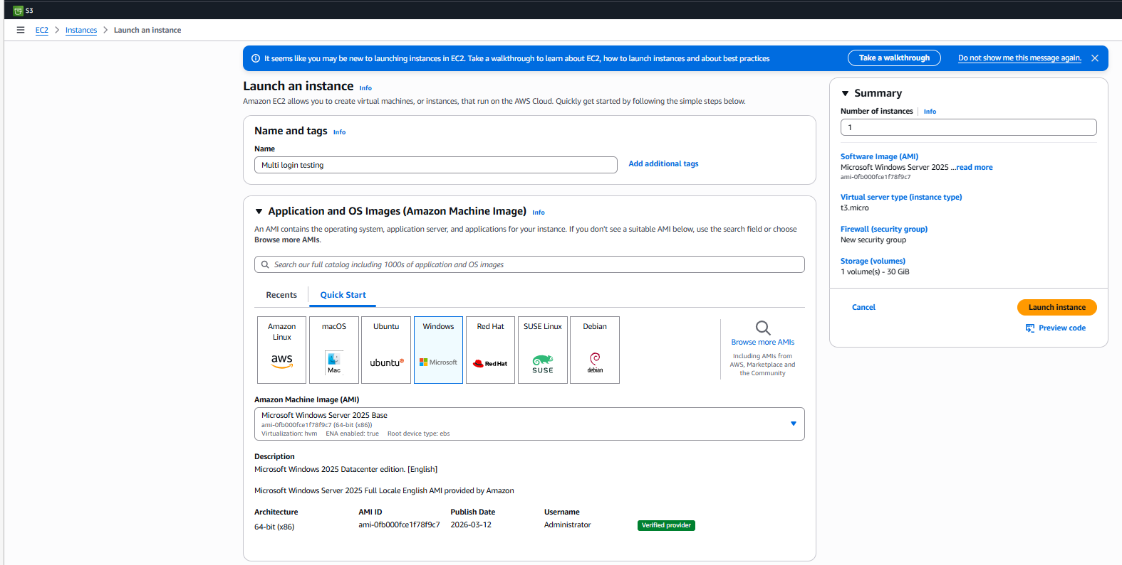
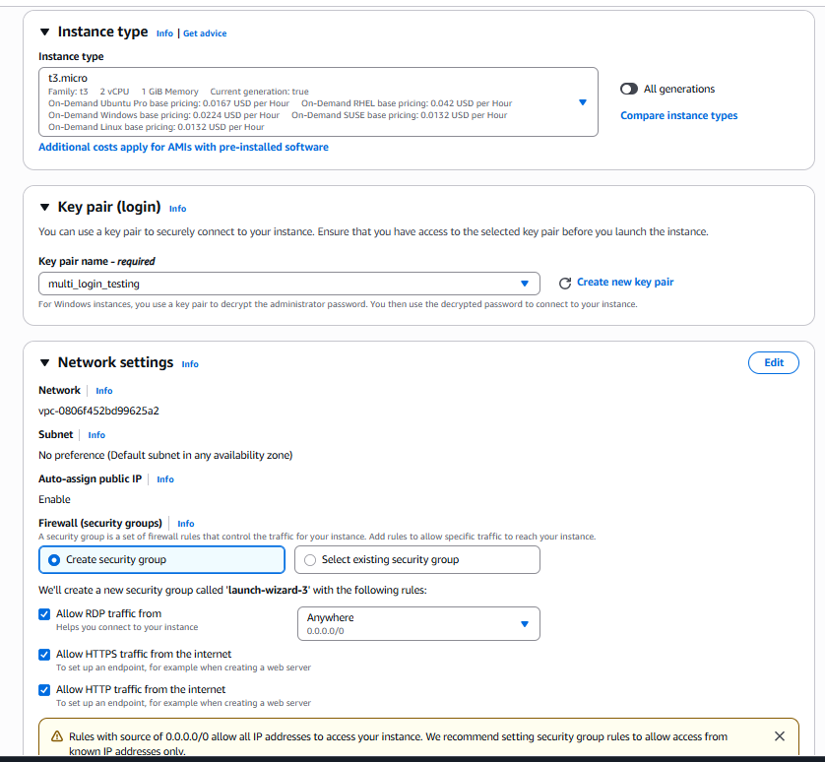
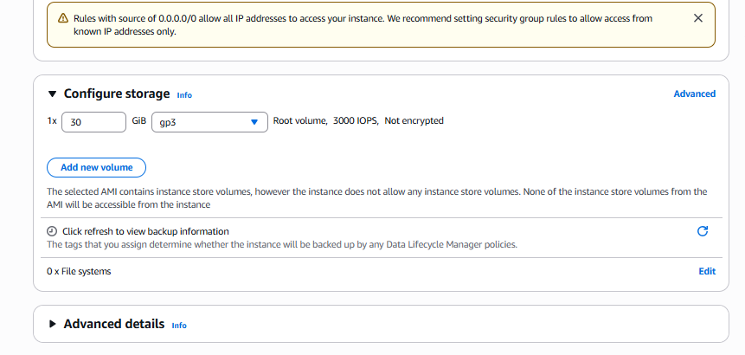
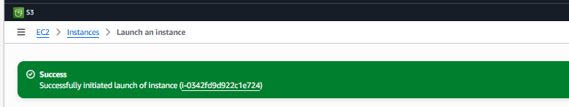

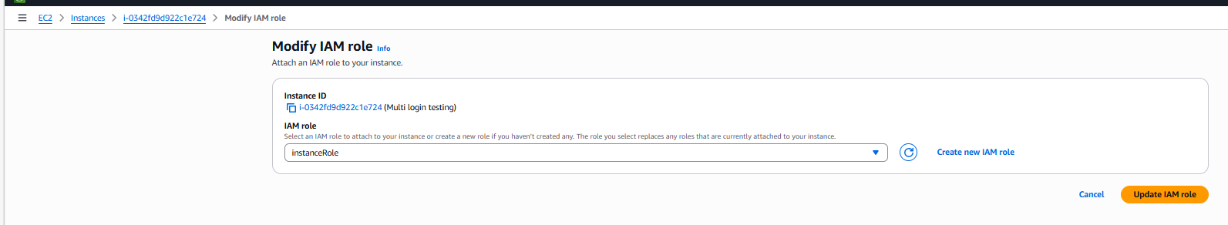
Connect the RDP:
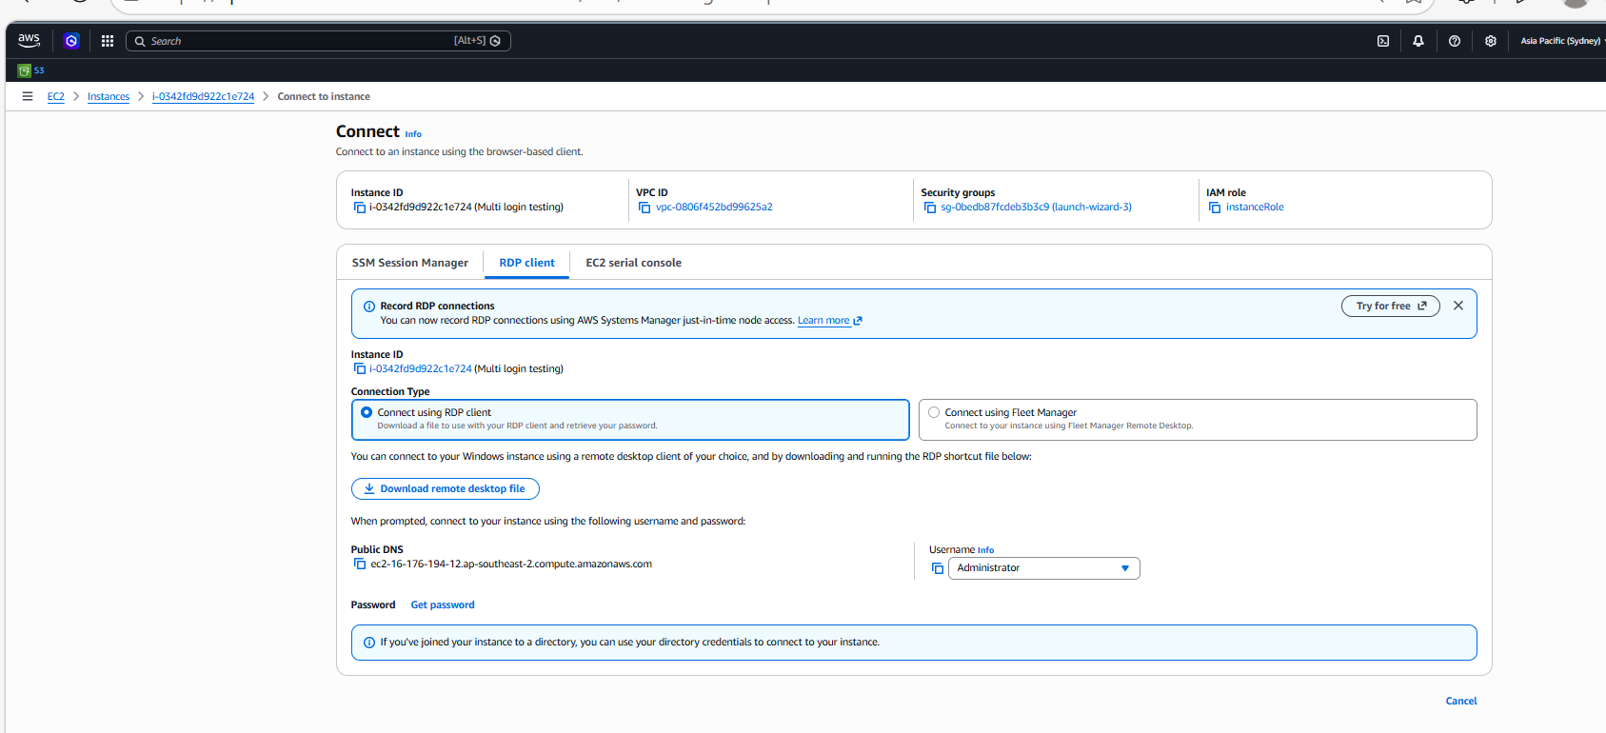

Step 2: Open Group Policy (inside EC2)
Once you are logged into EC2:
- Press:
Windows + R
- A small Run box opens
- Type:
gpedit.msc
- Click OK
👉 Now Group Policy Editor opens (inside EC2)
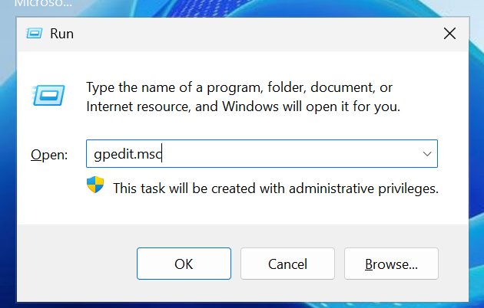

Step 3: Navigate to the setting
Inside that window:
Follow this exactly:
Computer Configuration
→ Administrative Templates
→ Windows Components
→ Remote Desktop Services
→ Remote Desktop Session Host
→ Connections
Just click arrow (▶) to expand each folder
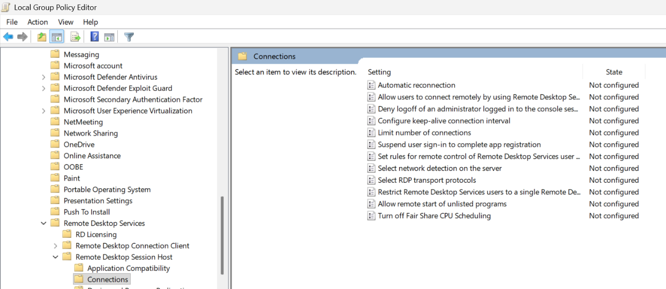
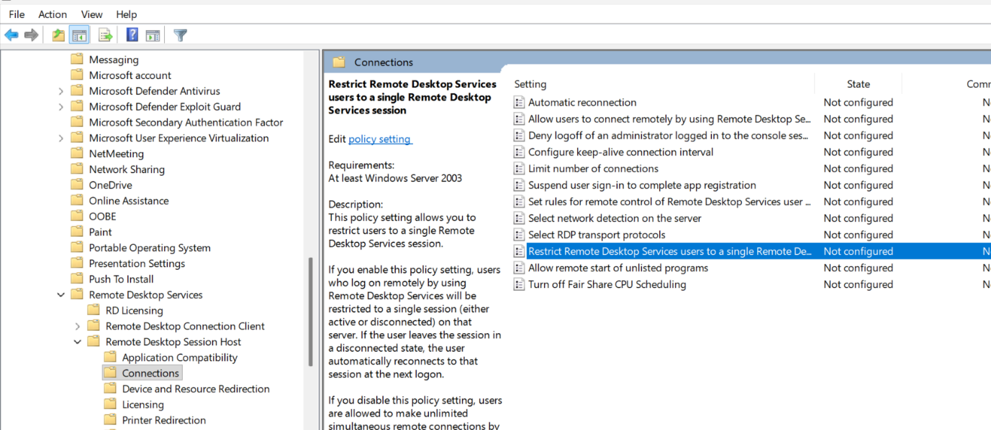

Step 4: Change settings (same place)
In the Connections folder:
- Open:
👉 Restrict Remote Desktop Services users to a single session
→ Set to Disabled
- Open:
👉 Limit number of connections
→ Set to Enabled → Put value (5 or 10)
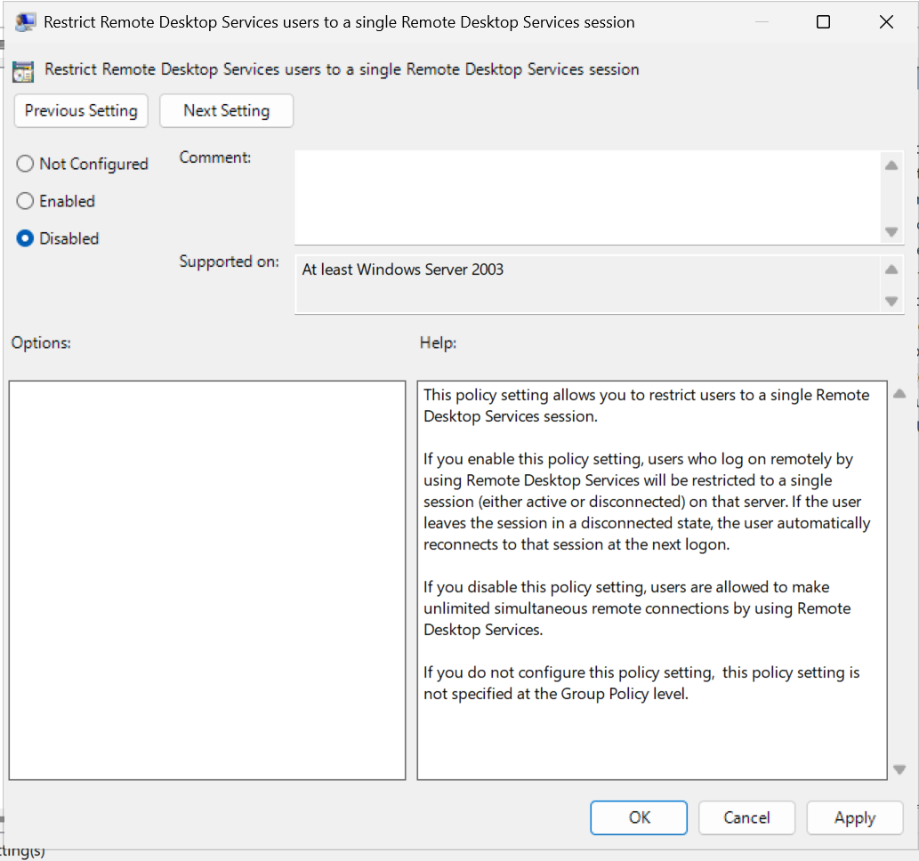
Limit number of connections;
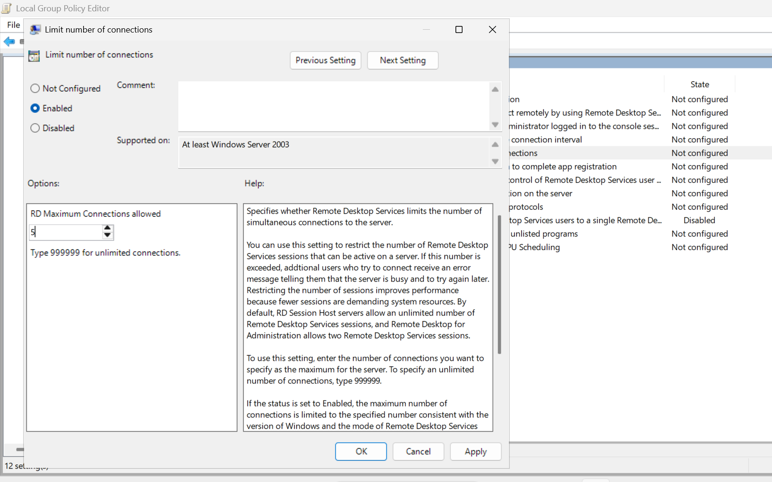

Step 5: Restart EC2
- Click Start → Restart
PART 2 — How to Create Multiple Users (inside EC2)
Do this inside your Windows EC2 server (connected via RDP)

Step 1: Open Computer Management
- Right-click Start button
- Click:
👉 Computer Management
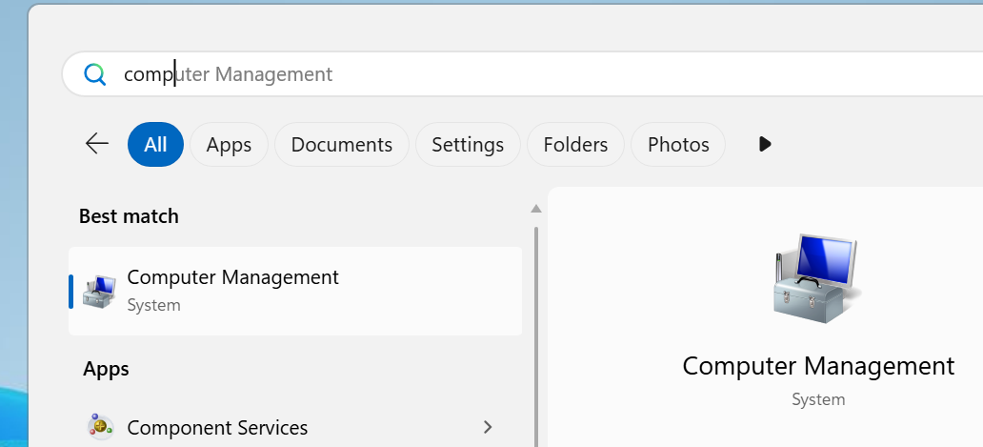
Step 2: Go to Users
Inside the window:
Computer Management
→ Local Users and Groups
→ Users
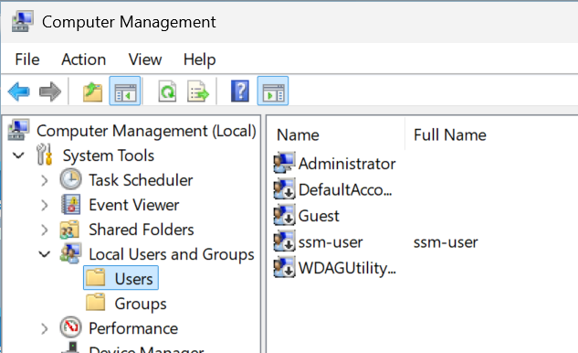

Step 3: Create new users
- Right-click in empty space → click New User
Fill details:
- Username: user1
- Password: (set password)
- Uncheck:
❌ User must change password at next login
- Check:
✅ Password never expires (optional)
Click Create
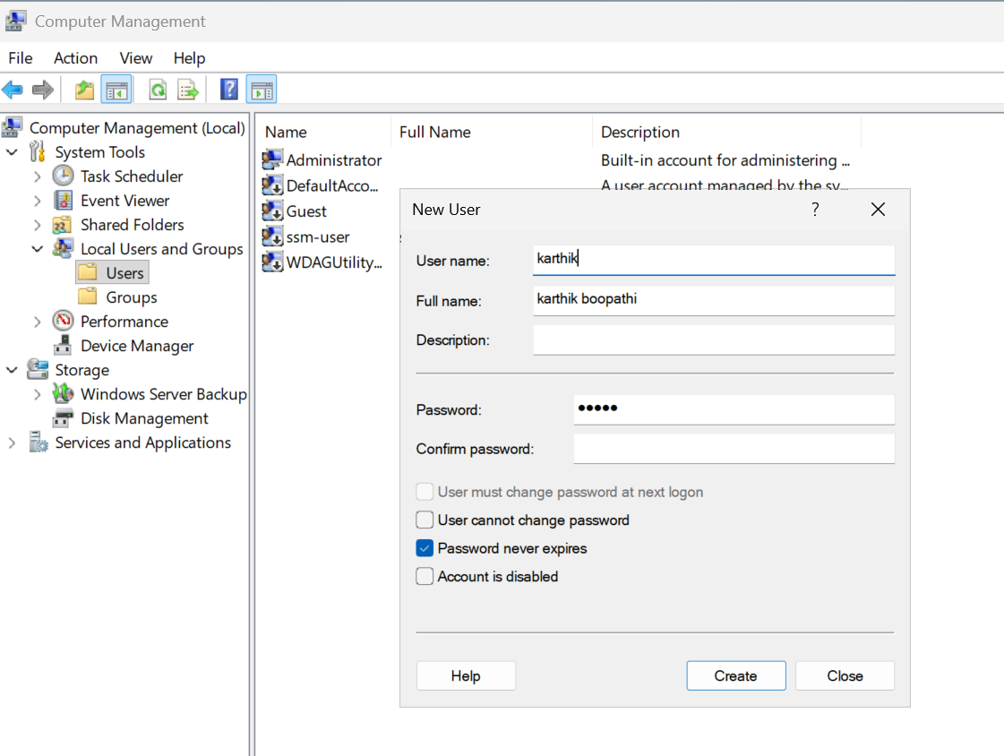

Repeat
Create:
- user1
- user2
- user3
User-2 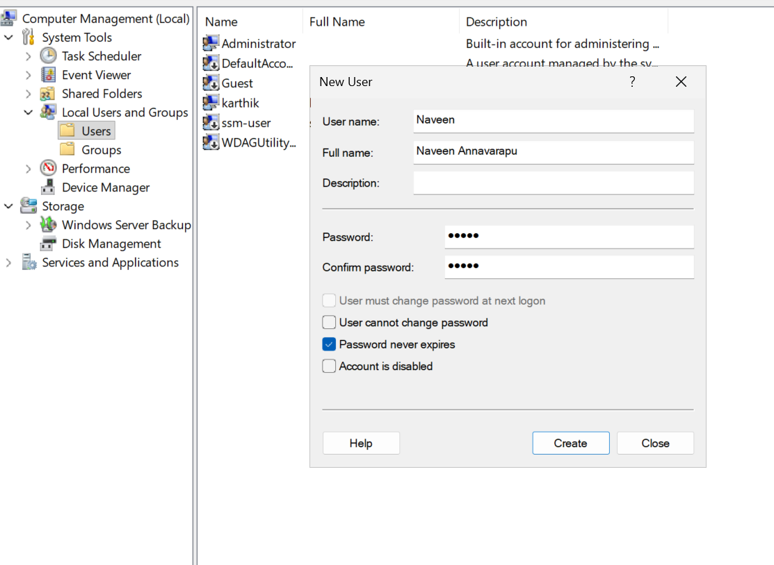
Part-3:

Next IMPORTANT step (Don’t skip)
After creating users:

Give Remote Desktop access
• Press:
Windows + R
• Type:
SystemPropertiesRemote
• Click:
Step 2: Enable Remote Desktop (check this)

In that window:

Make sure this is selected:

Allow remote connections to this computer

If not selected → select it

Step 3: Click “Select Users”
Click button:
Select Users…

A new popup opens:
Remote Desktop Users

Step 4: Click “Add”
In that popup, click:
Add…

Another small window opens:
Select Users

Step 5: Enter usernames

In the box:

Enter the object names to select

Type your users like this:

karthik
user1
user2
You can add:
One by one OR
All together (separate by space or semicolon)
Step 6: Check names
Click:
Check Names
If correct:
Names will underline / auto-format
Step 7: Confirm
Click:
OK
Click:
OK again
Click:
Apply → OK
Select Users